# Examples of Test Scenarios and Test Cases

This document illustrates the **concepts** of **test scenarios** and **test cases** through a simple water boiler system (hardware + software), which should be tested.

## Testing a Water Boiler

As a QA engineer, you are assigned to **test** a simple electrical **water boiler**. The water boiler consists of two parts:

* Electric **water kettle** with 1.0-liter capacity (1500 watts of power)
* **Power base**, used to plug on the boiler cordlessly

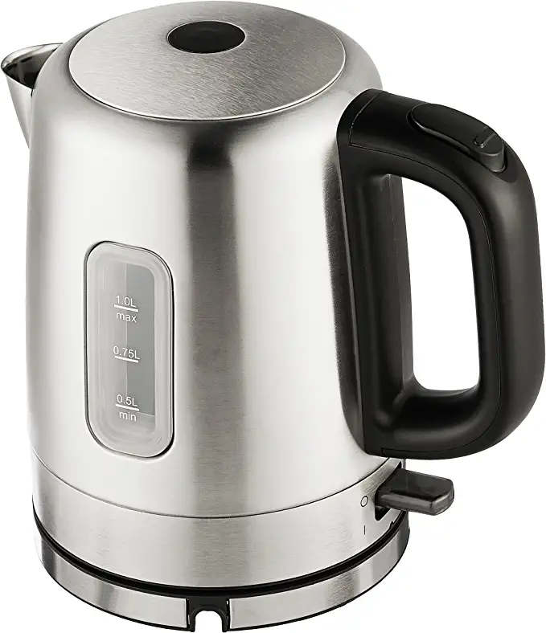 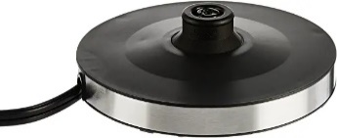

The boiler has **two buttons**:

* **Mechanical button** to **open the lid**. The lid is closed by hand, without any button.
* **Switch on/off button** to start boiling the water.

When the boiler is **plugged-in the power base**, and the power base is **plugged** in the electrical network, and the boiler holds **enough water** (at least 0.1 liters), the boiler starts boiling.

* It takes 2-3 minutes for the water to get hot. When the **water gets hot**, the **boiler automatically stops** (its start button gets into "**off**" state).
* When the water is **hot** and the boiler is **switched on**, it **automatically switches off** after 0.5-2 seconds.
* When the boiler is **empty** or almost empty (holding less than 0.1 liters) and the boiler is **switched on**, it **automatically switches off** after 0.5-2 seconds.

Your task is to think about the **test scenarios** and **test cases** to test the electrical water boiler. Describe the **test scenarios** and each **test case** in the following format:

### Test Scenario: Boil a Water

|  |  |
| --- | --- |
| Test case | **Boil 1 liter of water 🡪 success** |
| Description | Put 1 liter of water, start the boiler, and wait until it gets hot. |
| Steps | 1. Fill 1 liter of cold water in the boiler and close the boiler lid. 2. Plug the power base in the electrical network. 3. Plug the boiler into the power base. 4. Switch on the boiler. 5. Wait until the water gets hot and the boiler automatically switches off (2-3 minutes). |
| Expected results | The brew process should complete in less than 4 minutes.  The water should get hot.  The boiler should automatically power off when the water gets too hot.  The boiler lid should stay closed. |

|  |  |
| --- | --- |
| Test case | **Boil an empty boiler 🡪 fail** |
| Description | Try to boil an empty boiler (no water inside) and make sure the boiling stops (automatically switches off) almost immediately after starting. |
| Steps | 1. Empty the boiler (leave it without any water) and close the boiler lid. 2. Plug the power base in the electrical network. 3. Plug the boiler into the power base. 4. Switch on the boiler. 5. Wait until the boiler automatically switches off (1-2 seconds). |
| Expected results | The brew process should stop immediately after started (in 1-2 seconds).  The boiler should be in switched off state (to prevent overheating).  The boiler lid should stay closed. |

|  |  |
| --- | --- |
| Test case | **Boil already boiled water 🡪 success** |
| Description | Boil some water and try to boil it again to ensure the boiler will stop automatically. |
| Steps | 1. Fill 1 liter of cold water in the boiler and close the boiler lid. 2. Plug the power base in the electrical network. 3. Plug the boiler into the power base. 4. Switch on the boiler. 5. Wait until the water gets hot and the boiler automatically switches off (2-3 minutes). 6. Switch on the boiler again. 7. Wait until the boiler automatically switches off (in 1-5 seconds). |
| Expected results | After the initial water boiling, the water should be hot.  After the second brew process is started, the boiler should be automatically switched off after < 5 seconds (to prevent overheating).  The boiler lid should stay closed all the time. |

### Test Scenario: Lid Test

|  |  |
| --- | --- |
| Test case | **Open the lid** |
| Description | Check if the "open lid" button works as expected. |
| Steps | 1. Close the boiler lid. 2. Click the “open lid” button. |
| Expected results | The boiler lid should open. |

|  |  |
| --- | --- |
| Test case | **Close the lid** |
| Description | Check if the "open lid" button works as expected. |
| Steps | 1. Open the boiler lid. 2. Push it down to close it. |
| Expected results | The boiler lid should stay closed. |